## User Registration (Diagram 2.1 Version 1.0 11/24/2015)::

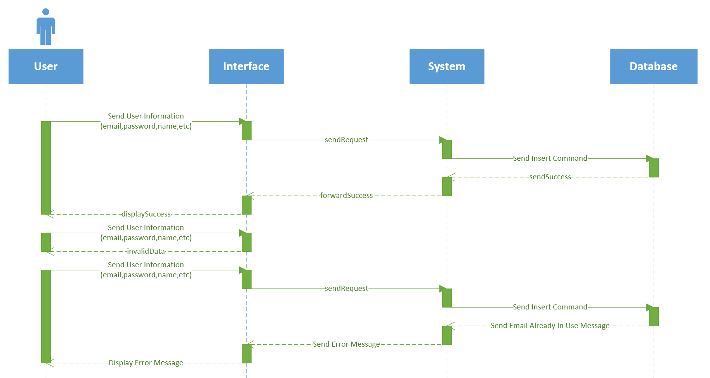

# User Login (Diagram 2.2 Version 1.0 11/24/2015)::

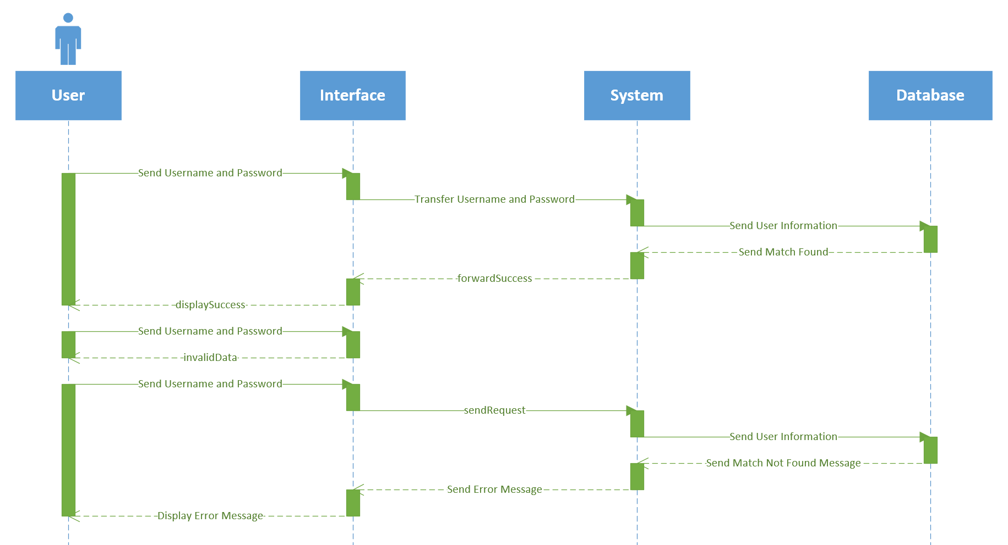

# User Logout (Diagram 2.3 Version 1.0 11/24/2015):

